Pathfinding Assignment

Alex Scapillati

07/02/2020

University of Central Lancashire

Link to the video: [https://www.youtube.com/watch?v=i02Hvj537XI](https://www.youtube.com/watch?v=i02Hvj537XI&feature=youtu.be)

Select the Pathfinding Algorithm:

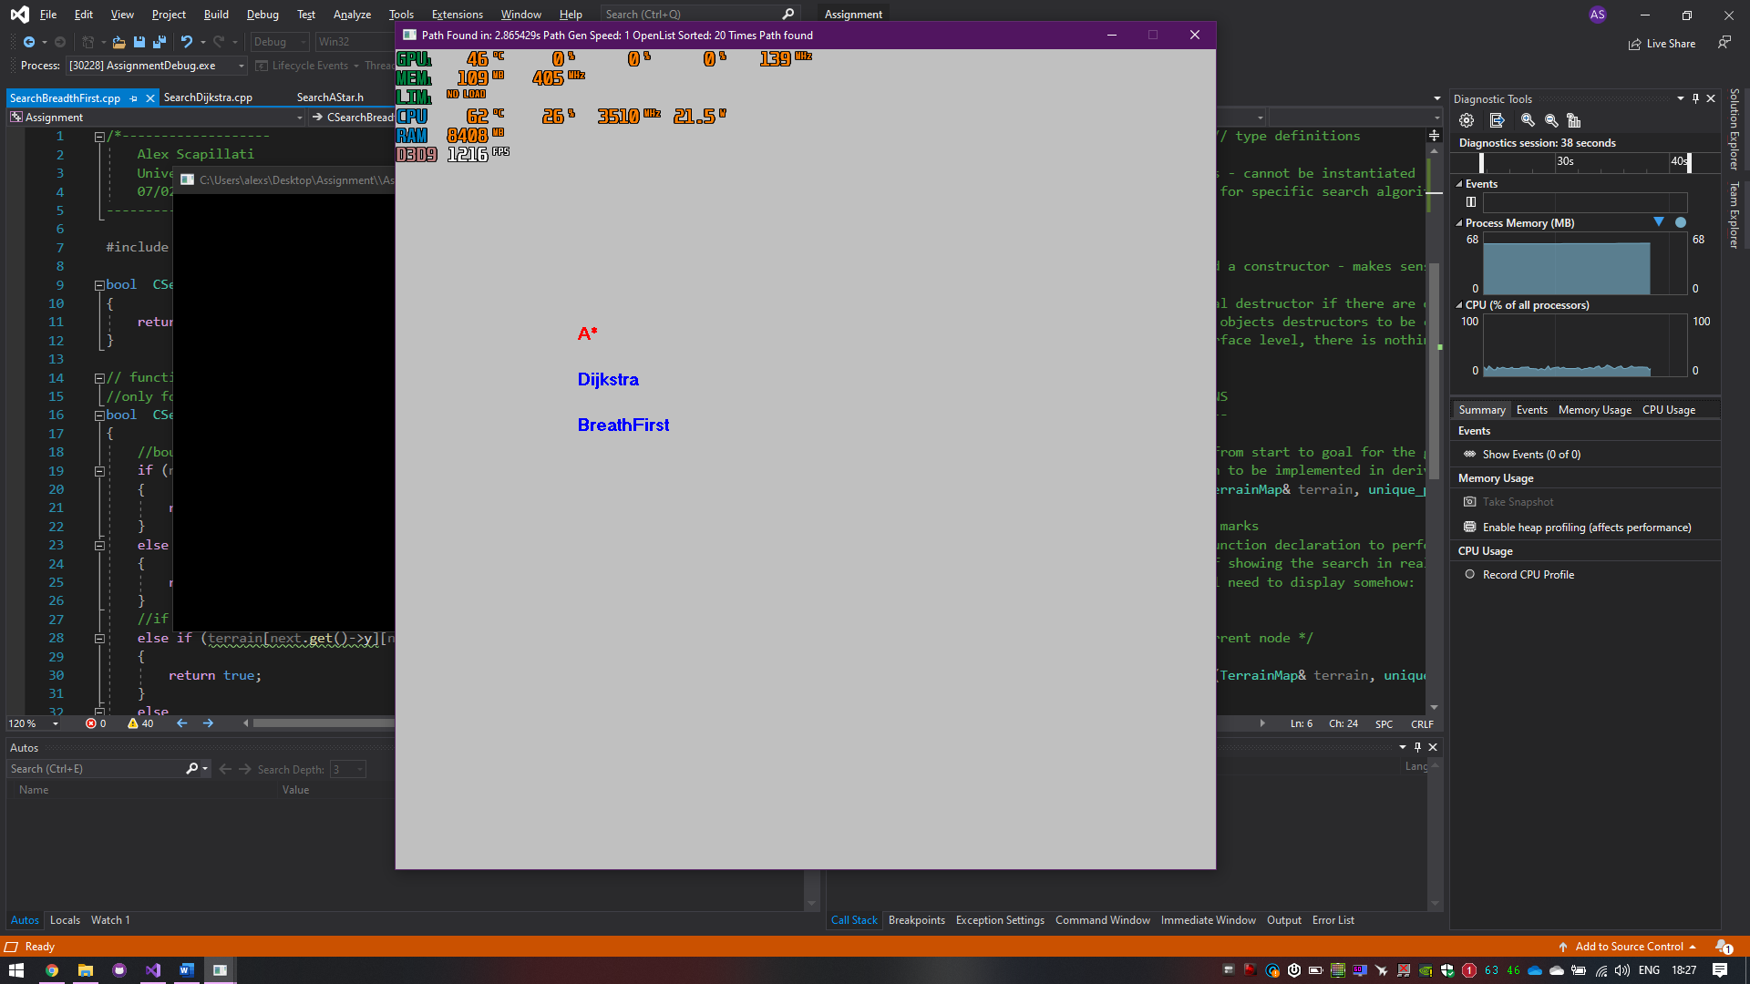

Select the map:



Path visualization:

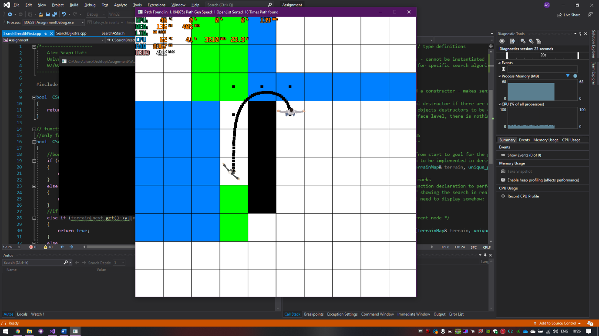

Path real time searching visualization:

